
FATIMA JINNAH WOMEN UNIVERSITY
RAWALPINDI
Department of Software Engineering

SUBJECT: CLOUD COMPUTING LAB
Name: Saira Ejaz
Reg No: 2023-BSE-057
Section: 5-B
LAB NO 3:
Task 1 – Handling Local and Remote Commit Conflicts (Pull vs Pull --rebase)
Steps:
- Open your repository on GitHub and edit the README.md file directly in the browser.
https://github.com/23-22411-057-sudo/Lab3
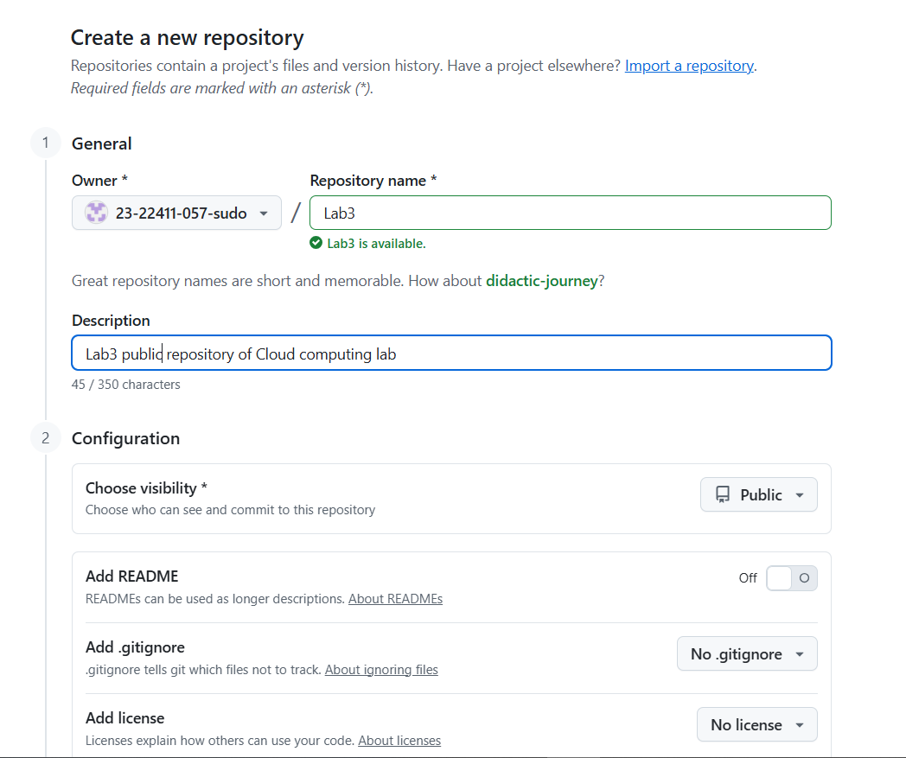
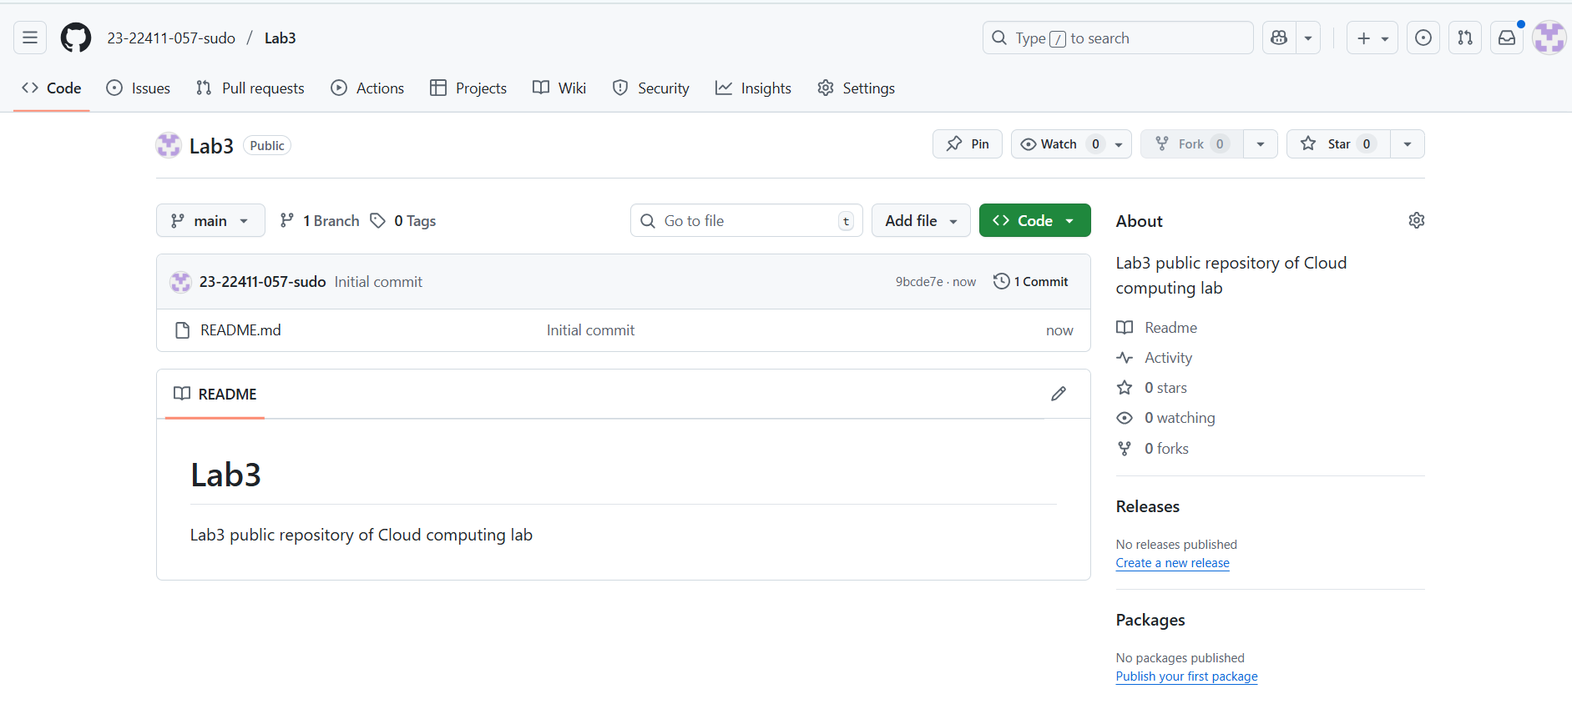
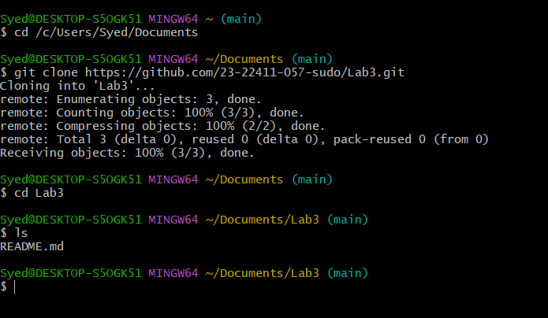
Add a new line such as:
This line was added remotely from GitHub.

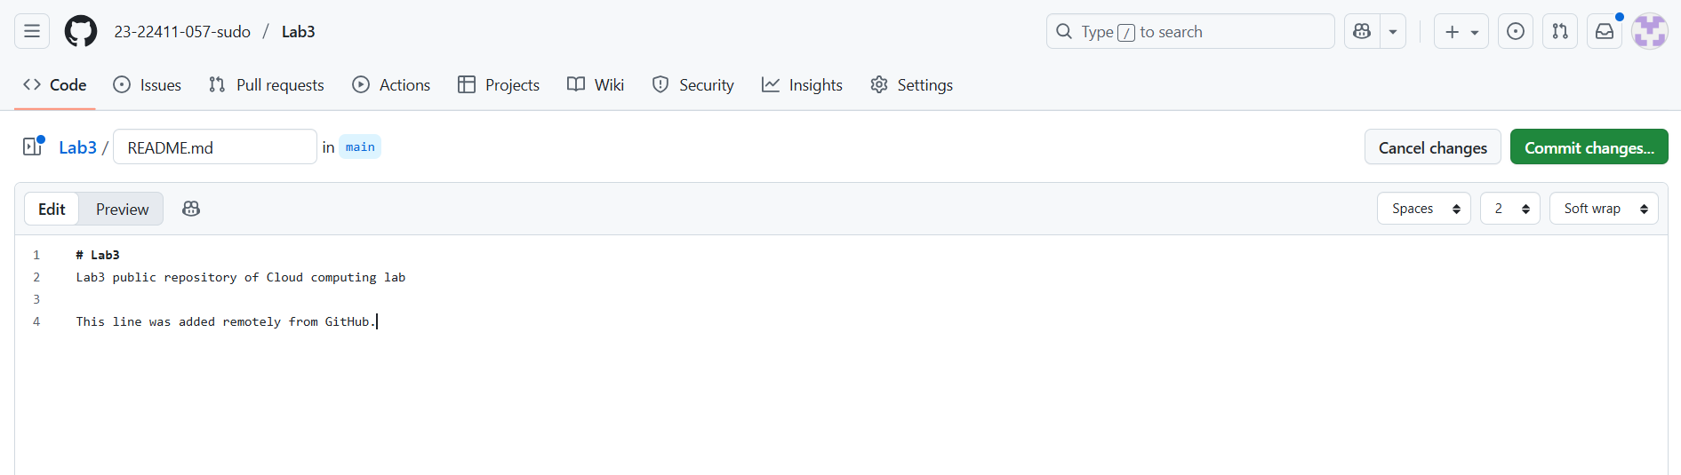

Commit your change on GitHub (e.g., message: Remote update to README).
Save a screenshot of your browser showing the change as remote_edit.png.
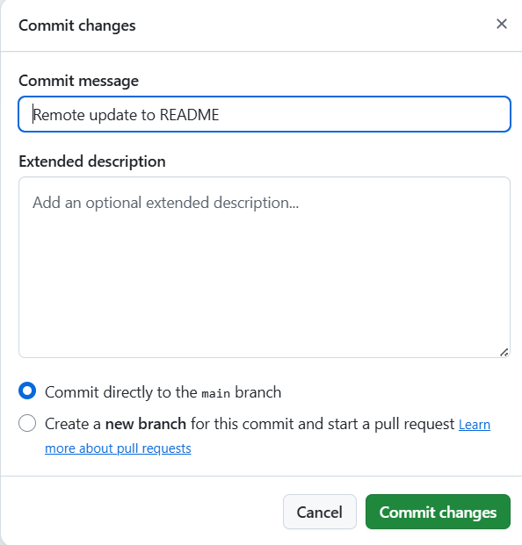
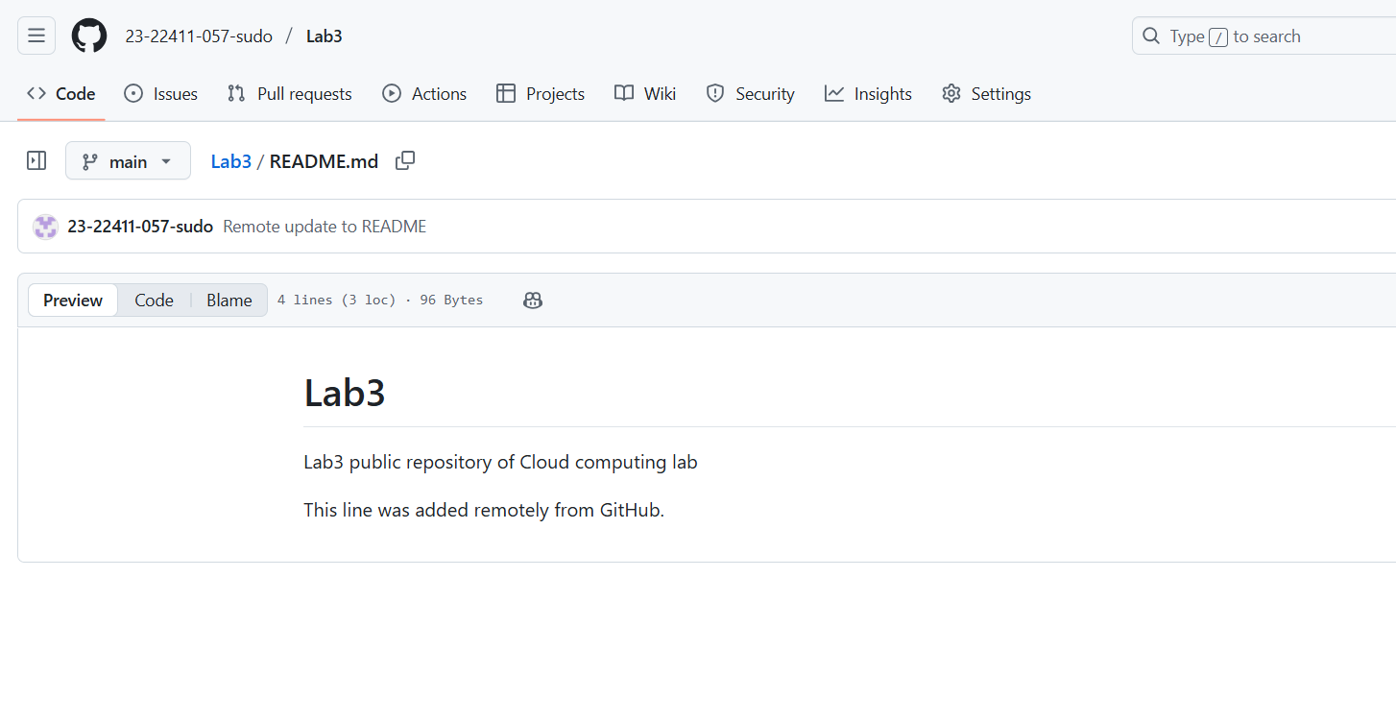
- On your local machine, open the same repository folder.
  - Edit the same README.md file locally, for example:
This line was added locally.
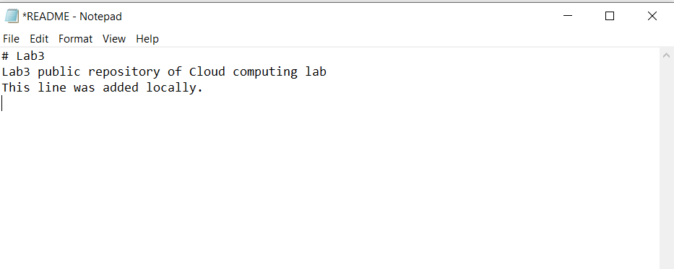
- Stage and commit your change:
git add README.md
git commit -m "Local update to README"
Save a screenshot of your terminal as local_commit.png.
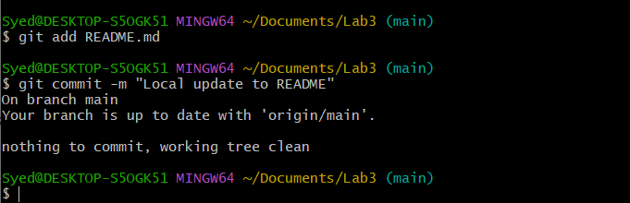
- Try to push:
git push origin main
You’ll see an error message similar to:
hint: Updates were rejected because the remote contains work that you do not have locally.
Save a screenshot of this error as push_error.png.
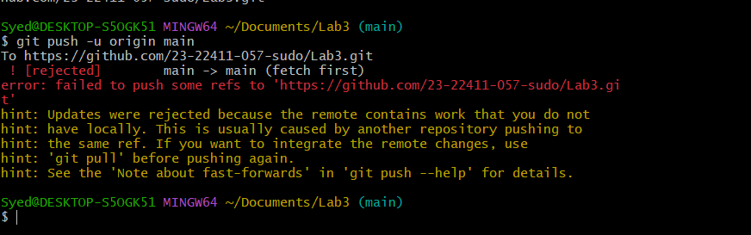
- To fix this, pull the latest changes from remote:
git pull --no-rebase origin main
Save a screenshot as merge_commit.png.
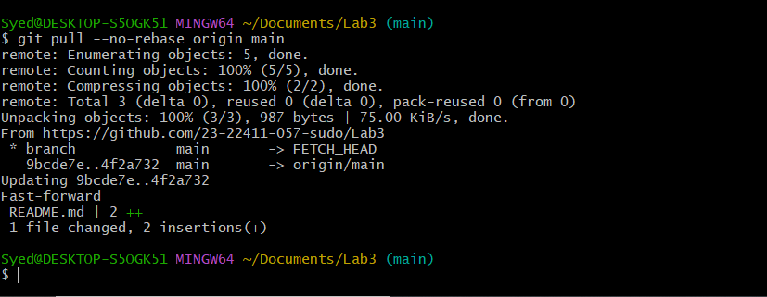
Push again:
git push -u origin main
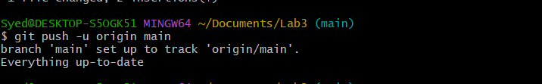
- Now repeat the same process, but this time use rebase instead of merge:
Make another remote edit on GitHub in README.md.
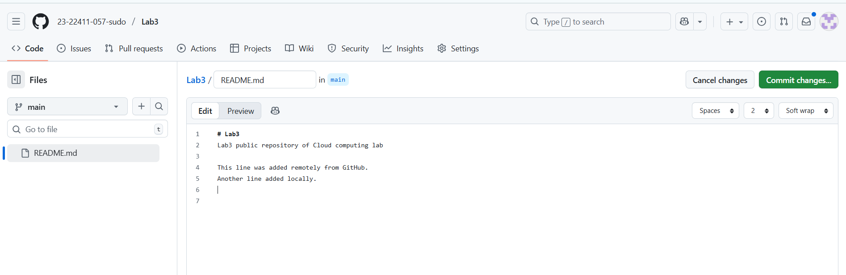
Then make another local edit and commit it.
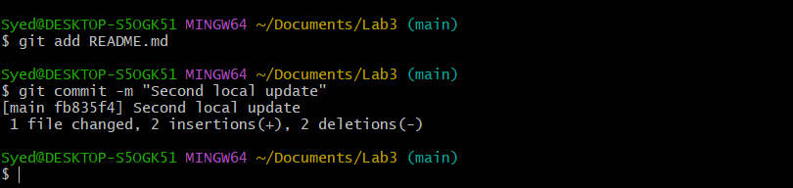
- Instead of using git pull, run:
git pull --rebase origin main
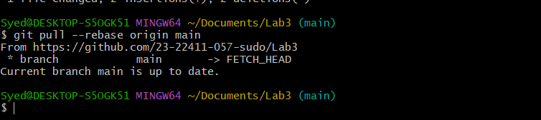
- Push again:
git push -u origin main
Have a screenshot as push_after_rebase.png.
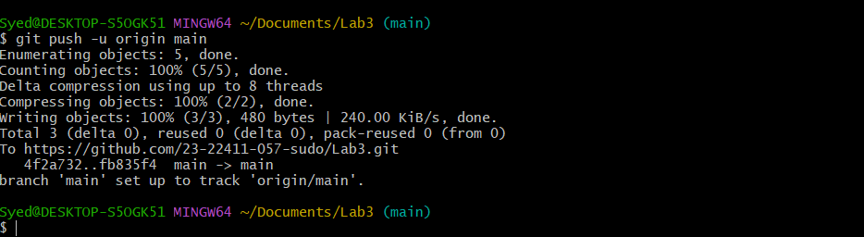
Task 2 – Creating and Resolving Merge Conflicts Manually
This task will help you understand how Git handles file conflicts when two people modify the same line of code differently.
Steps
- On GitHub (remote), open your README.md file and change an existing line.Change it to: This line was updated remotely again.
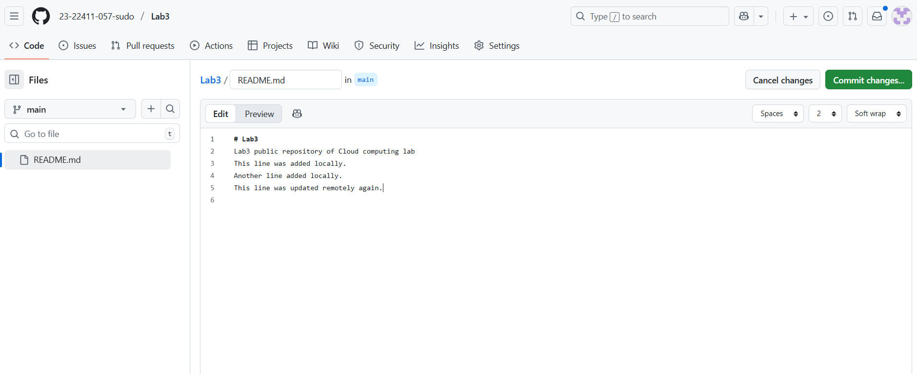
Commit your change with the message: Remote conflicting change
Save a screenshot as remote_conflict_edit.png.
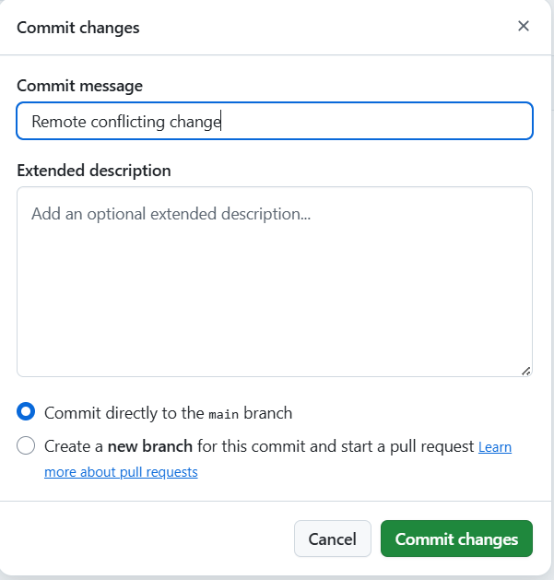
- On your local machine, edit the same line in the same file but make a different change:
- This line was updated locally at the same time.
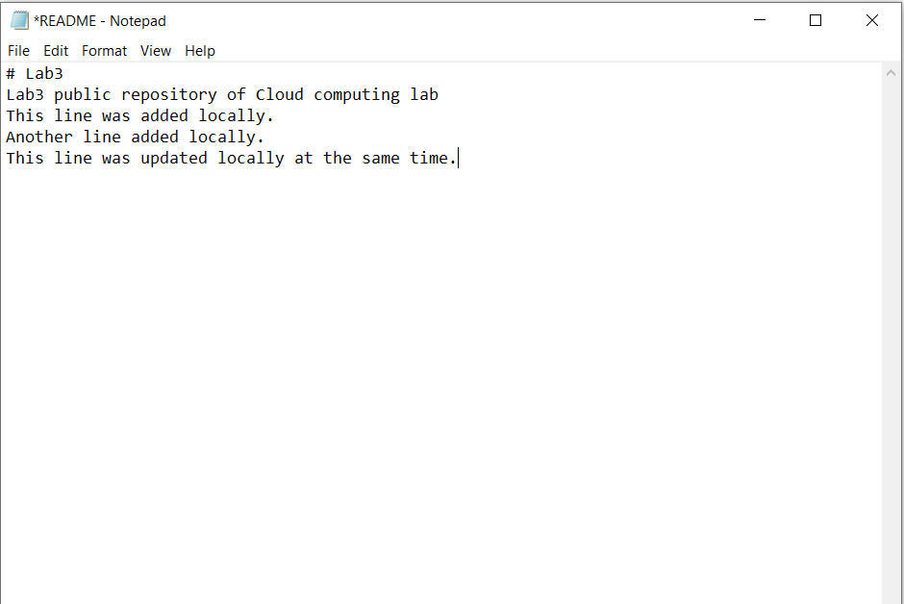
- Stage and commit your local change:
git add README.md
git commit -m "Local conflicting change
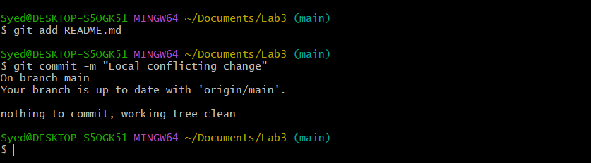
- Try to push:
git push -u origin main
The push will be rejected, since the remote version has conflicting changes.
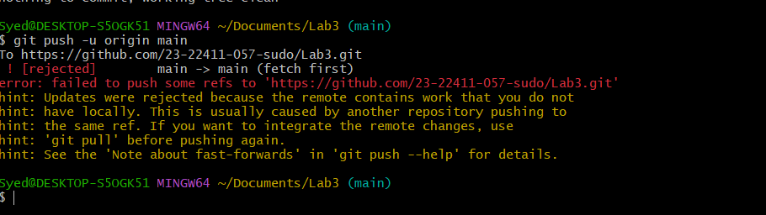
- Pull with rebase to bring in remote changes:
git pull --rebase origin main
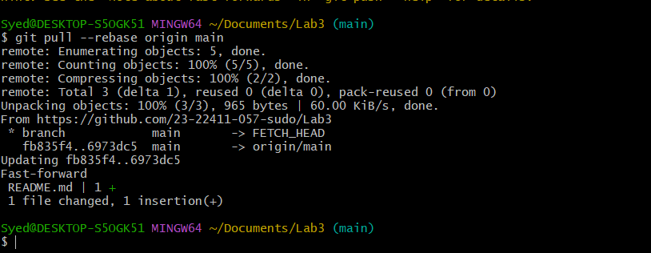
- Open the README.md file in your editor — you’ll see conflict markers like this:
Manually edit the file to keep the correct line (for example, merge both ideas).
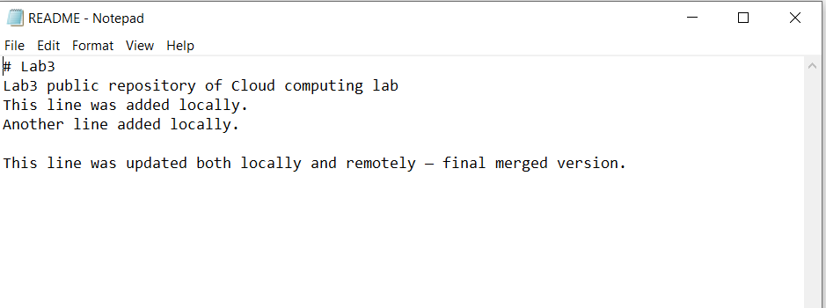
- After fixing the file, mark the conflict as resolved and continue the rebase:
git add README.md
git rebase --continue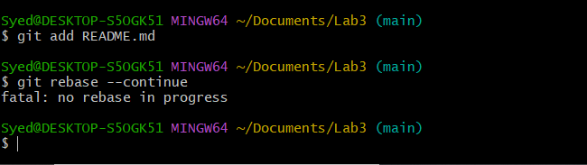
- Finally, push your changes:
git push -u origin main
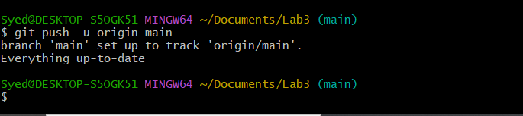
Task 3 – Managing Ignored Files with .gitignore and Removing Tracked Files
Steps
- Create a new folder named textfiles inside your repository:
mkdir textfiles
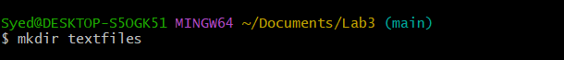
- Inside the textfiles folder, create three text files:
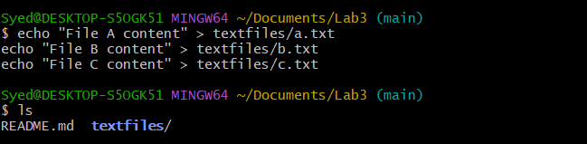
- Add and commit the new directory:
git add .
git commit -m "Added textfiles directory with three files"
git push origin main
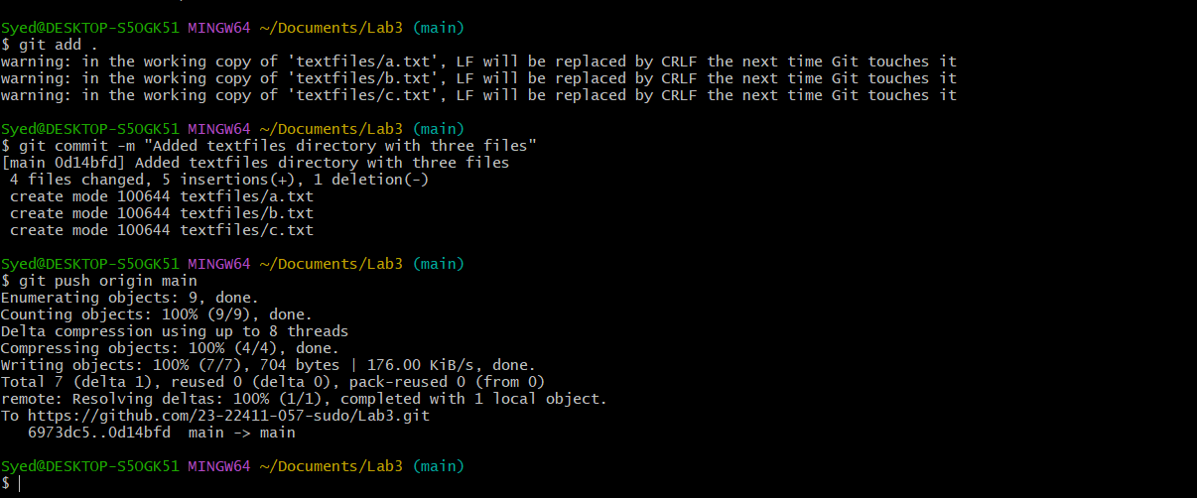
- Now, create a .gitignore file in the root of your repository:
echo "textfiles/*" > .gitignore
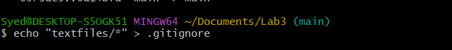
- Add and commit the .gitignore file:
git add .gitignore
git commit -m "Added .gitignore to ignore textfiles directory"
git push origin main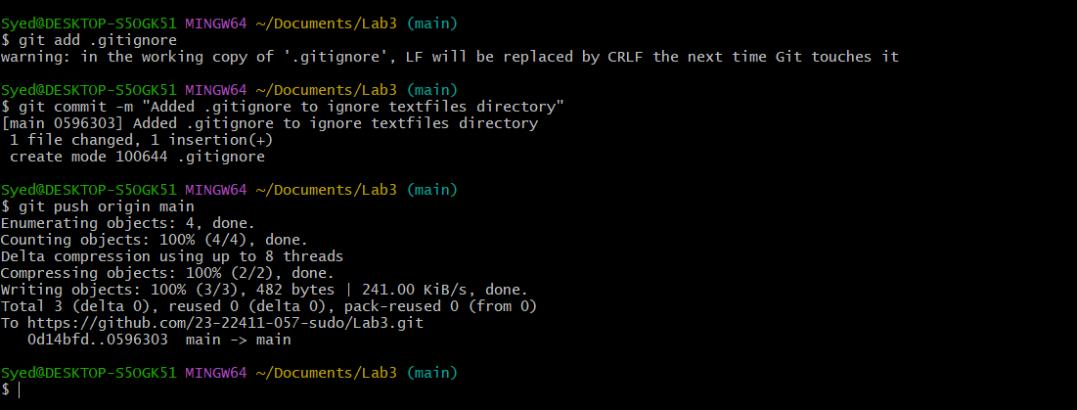
- Go to GitHub and check your repository — notice that the textfiles directory is still visible on the remote.
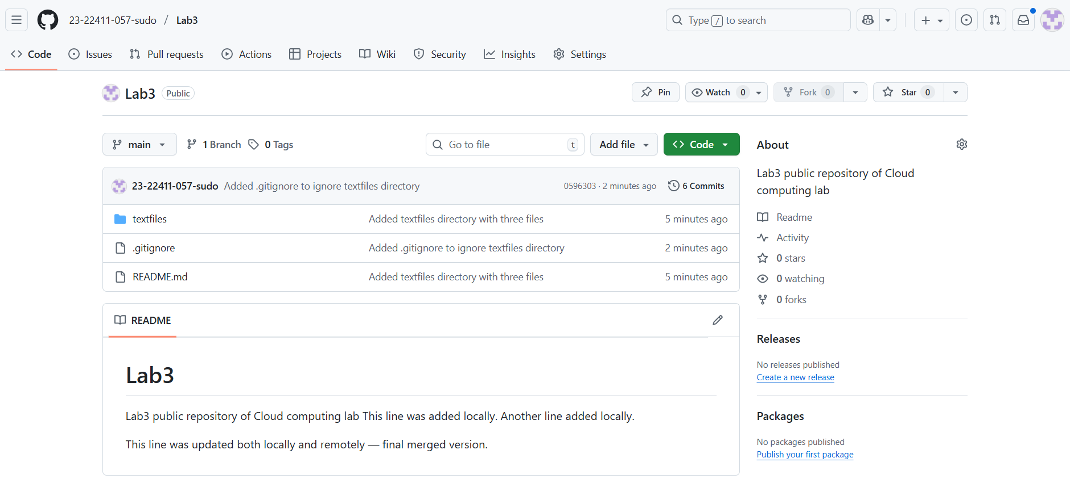
- To remove already tracked files from Git (but not from your local system), run:
git rm -r --cached textfiles
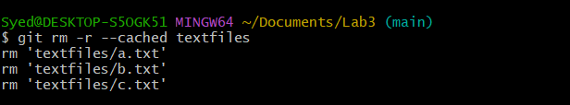
- Commit and push again:
git add .
git commit -m "Removed tracked textfiles directory"
git push origin main
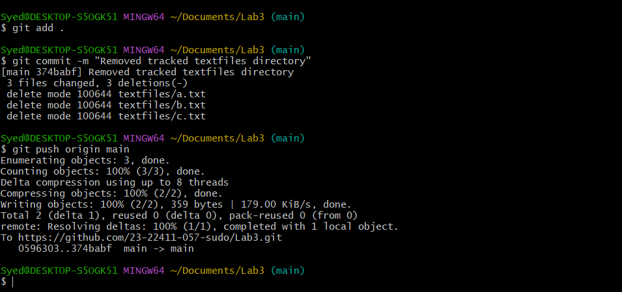
- Check your GitHub repository again — the textfiles folder should now be deleted remotely.
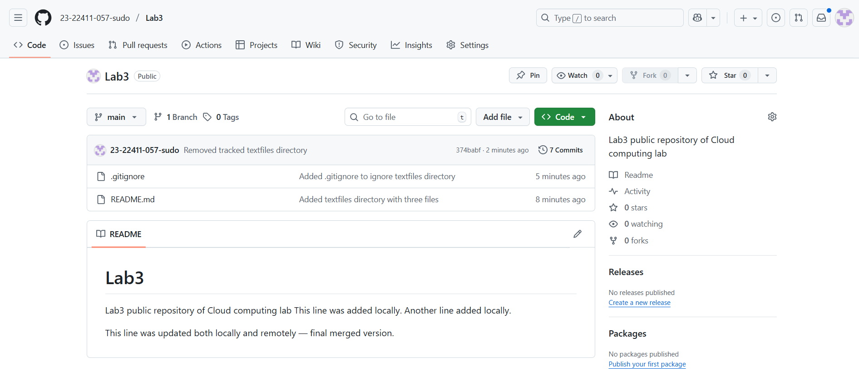
Task 4 – Create Temporary Changes and Use git stash
Steps
- Create a feature-branch.
git checkout -b feature-branch
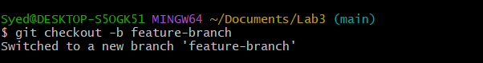
- Modify any file (for example, README.md) by adding a few test lines.
git add README.md
git commit -m "Changes the README.md file"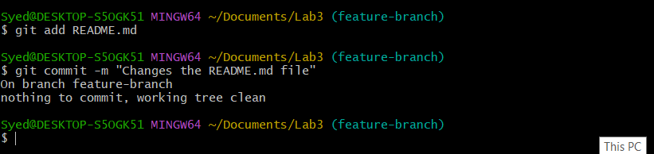
- Modify any file (for example, README.md) by adding a few new lines.
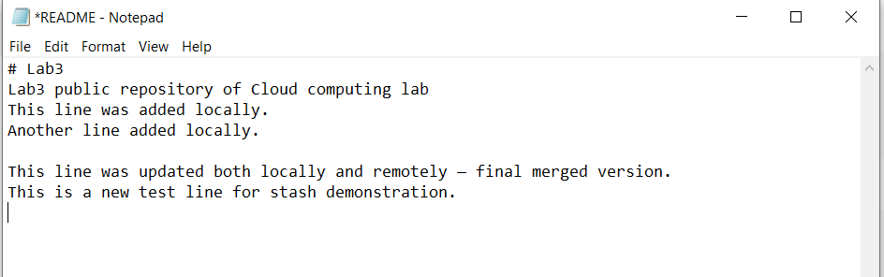
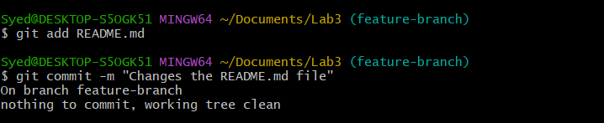
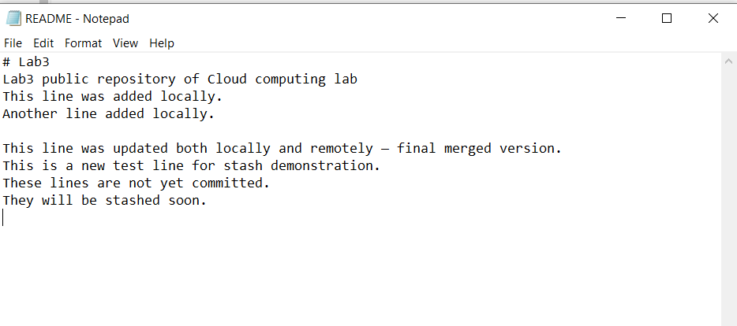
- Without committing or stashing the changes, try to switch to another branch:
git checkout main
You’ll see an error message similar to:
Please commit your changes or stash them before you switch branches.
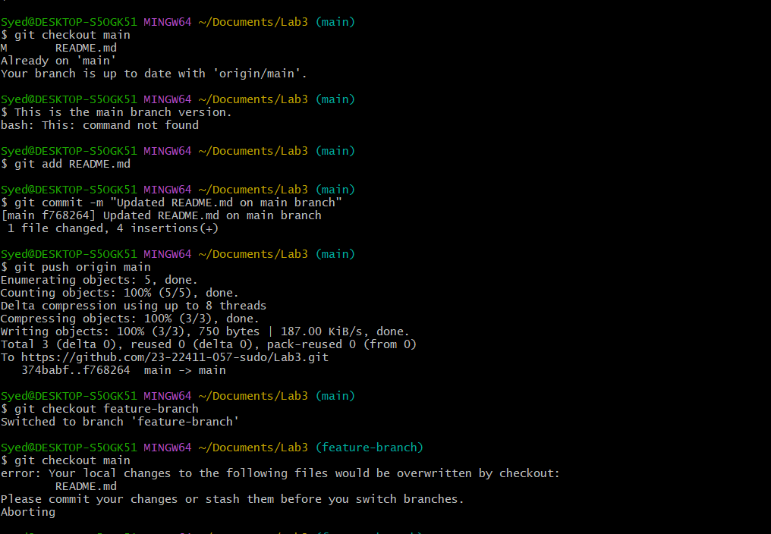
- To fix this, stash your changes:
git stash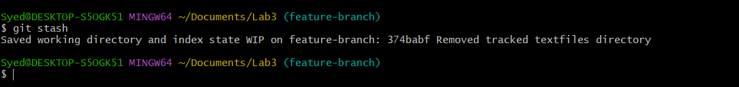
- Try switching branches again — it should now work:
git checkout main
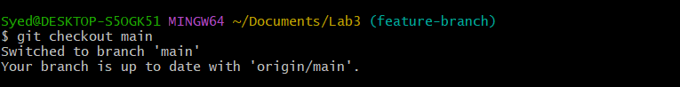
- Return to your previous branch (for example, feature-branch):
git checkout feature-branch
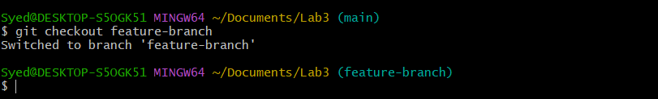
- Check your working directory status:
git status
It should show: nothing to commit, working tree clean
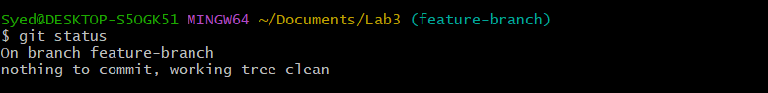
- Now restore your stashed changes:
git stash pop
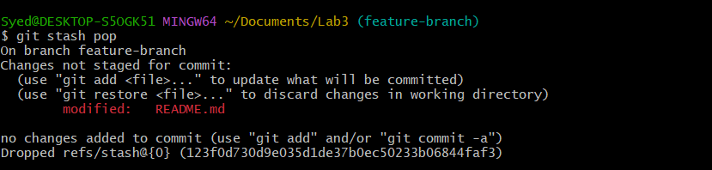
Task 5 – Checkout a Specific Commit Using git log
- View commit history:
git log --oneline
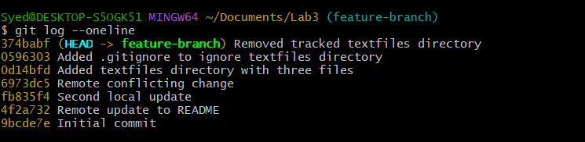
- Copy any previous commit hash (e.g., a1b2c3d).
- Checkout that commit:
git checkout <commit-hash>
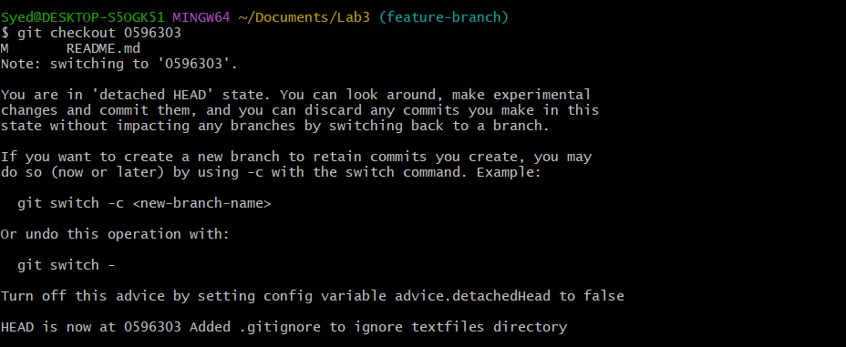
- To return to your main branch:
git checkout main
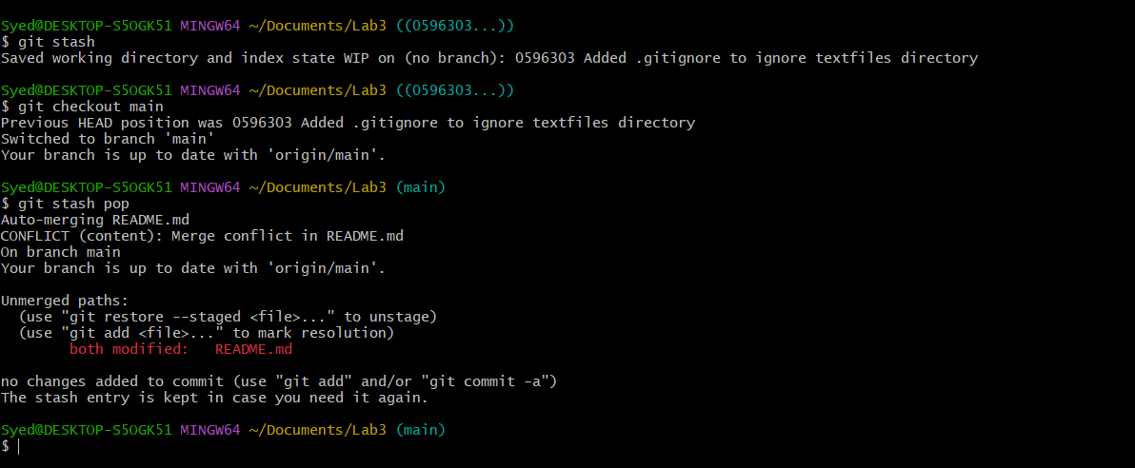
Task 6 – Resetting Commits (Soft vs Hard Reset) (With Verification Steps)
Steps
- Add a new line in any file and commit it:
# Edit any file (e.g., README.md), add a line
git add .
git commit -m "Added test line"
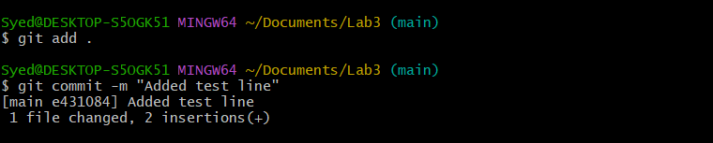
- Add another change and commit again:
# Edit the file again, add a different line
git add .
git commit -m "Second test commit"
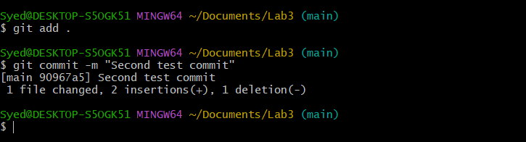
- View the history before reset:
git log --oneline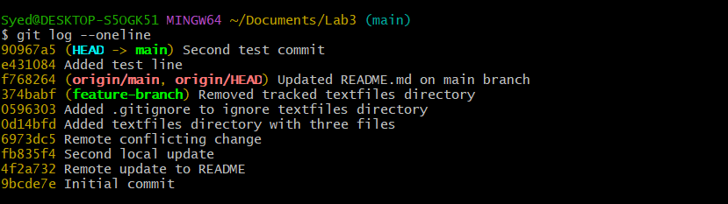
- Check file contents for both changes:
Open the edited file (e.g., README.md) and visually confirm BOTH added lines exist.
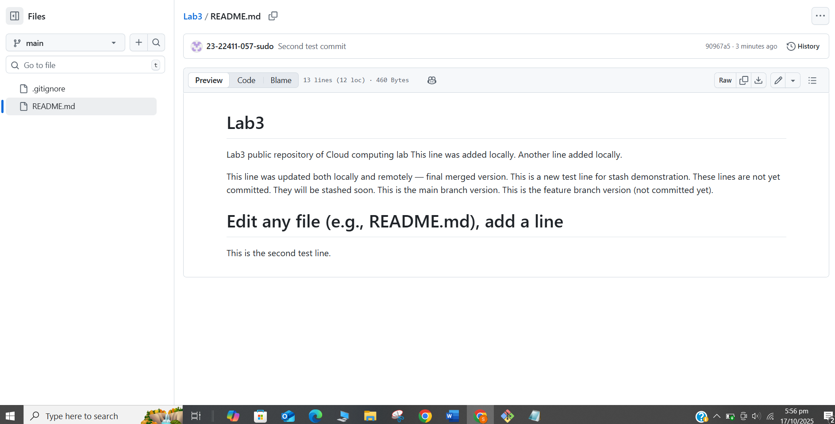
- Perform a soft reset (keeps changes in working directory)
git reset --soft HEAD~1
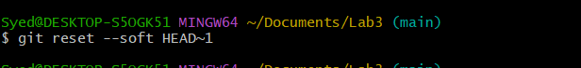
- Check commit history after soft reset
git log --oneline
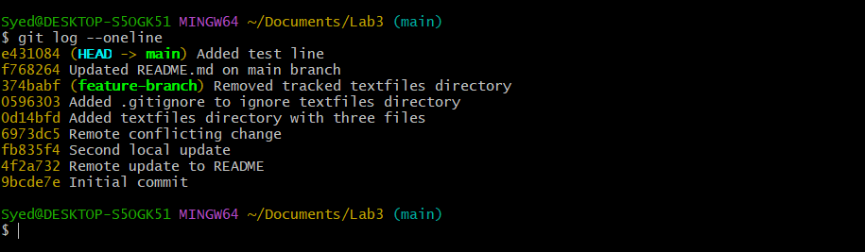
- Verify changes in the file:
Open the file again and confirm both edits are still present (nothing lost).
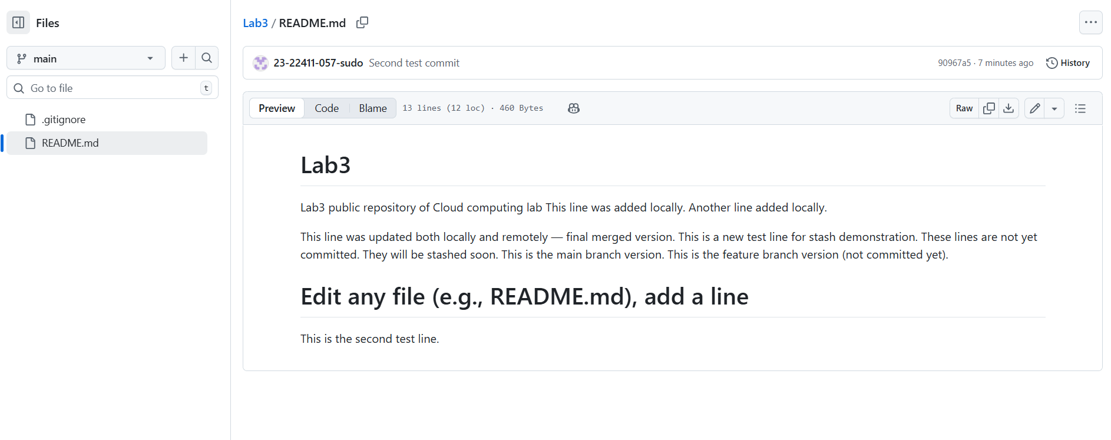
- Check git status
git status
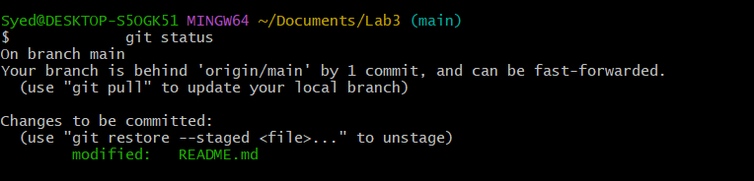
- Perform commit
git commit -m "Second Test commit"
  - Save a screenshot as file_after_hard_reset.png.
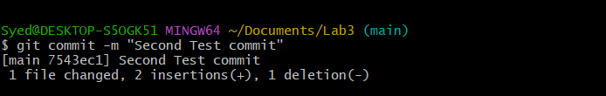
- Perform a hard reset (discards changes completely)
git reset --hard HEAD~1
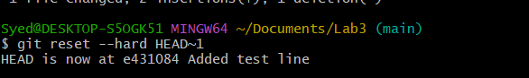
- Check commit history after hard reset
git log --oneline
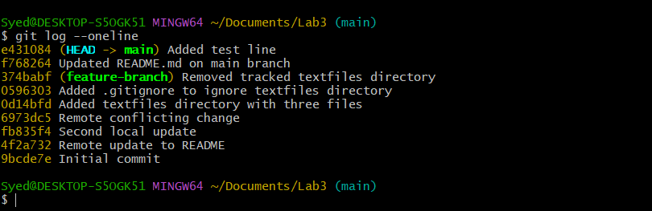
- Verify changes in the file:
Open the file and confirm the second edit is gone (reverted to previous commit).
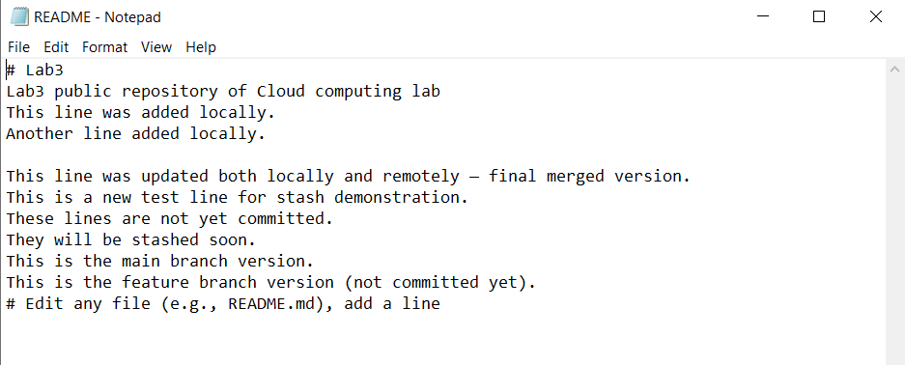
- Check git status
git status
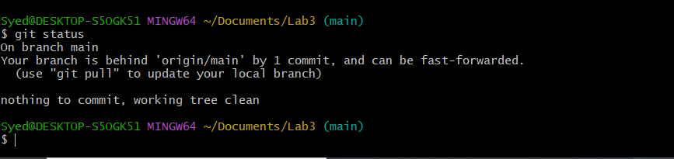
Task 7 – Amending the Last Commit
- Make a small change in any file.
- Stage it and commit:
git add .
git commit -m "Fix log message"
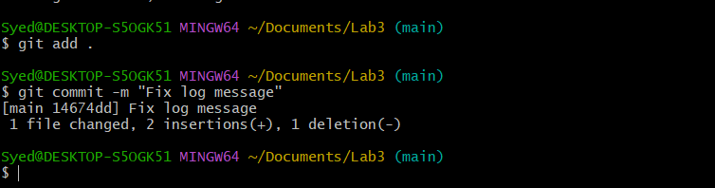
- Realize you forgot to change another file. Update it now.
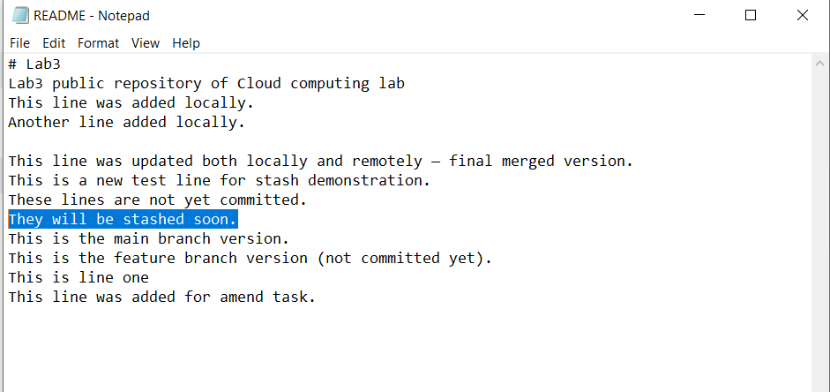
- Add it and amend the last commit:
git add .
git commit --amend
  - Save a screenshot as amend_commit.png.
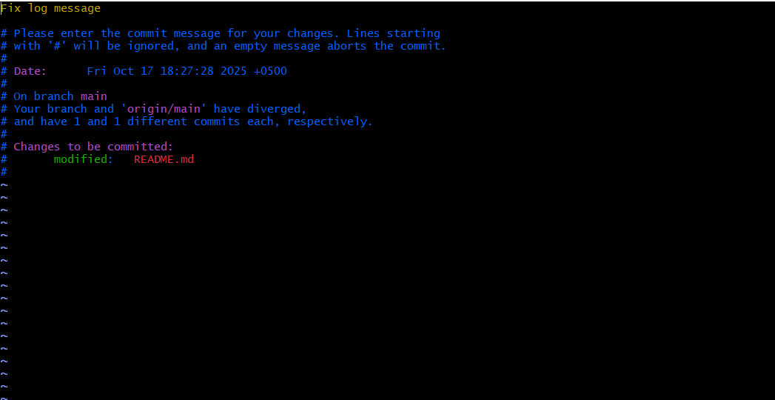
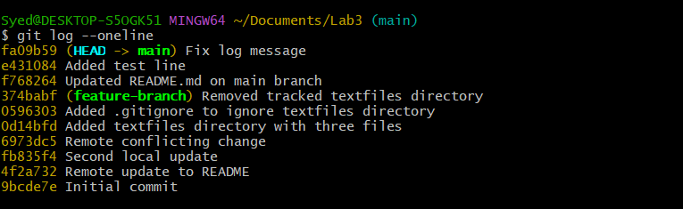
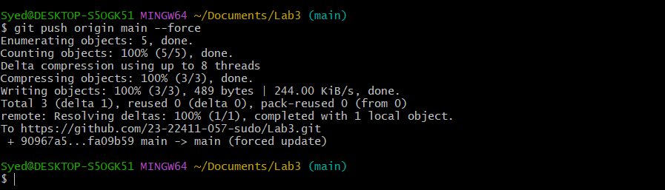
Task 8 – Reverting a Commit (Safe Undo on Remote Branch)
- Make a change and commit it:
echo "temporary text" >> temp.txt
git add .
git commit -m "Added temporary text file"
git push origin main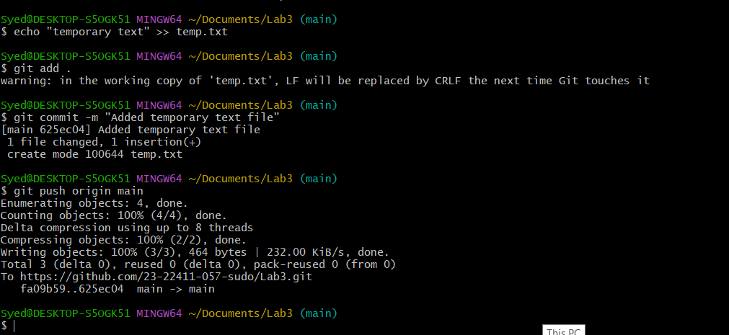
- Now revert that commit safely (do not delete it):
git log --oneline
git revert <commit-hash>
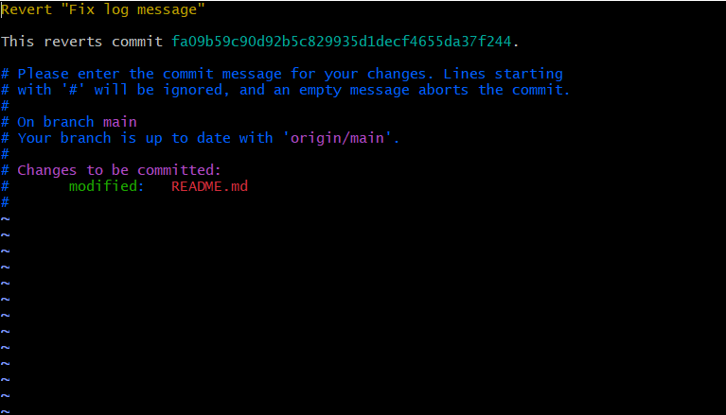
- Push the revert commit:
git push origin main
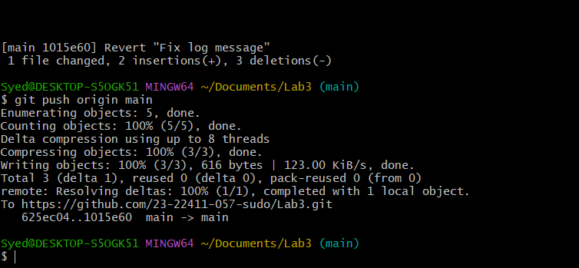
Task 9 – Force Push (With Caution)
- Create a new branch:
git checkout -b test-force
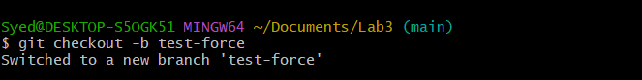

- Make and commit a small change.
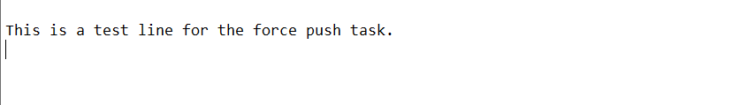
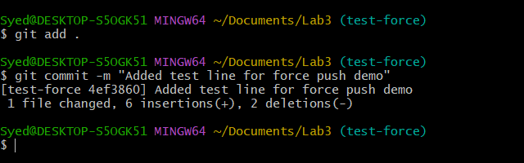
- Push it:
git push origin test-force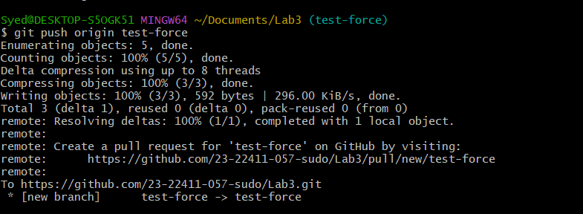
- Perform a hard reset:
git reset --hard HEAD~1
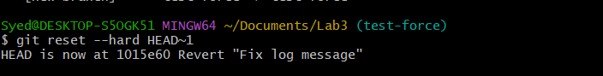
- Push again
git push origin test-force
Rejected by remote repository
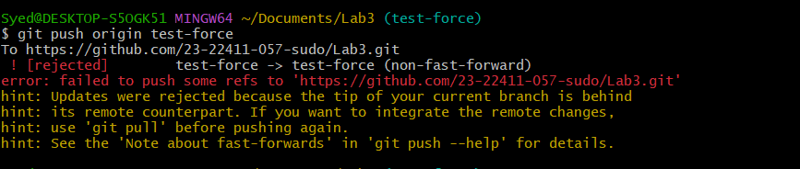
- Now force-push to remote:
git push origin test-force –force
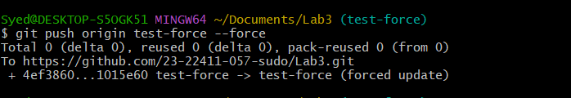
Task 10 – Running Gitea in GitHub Codespaces via Docker Compose
Steps
- Fork the Gitea Repository
Go to Gitea.
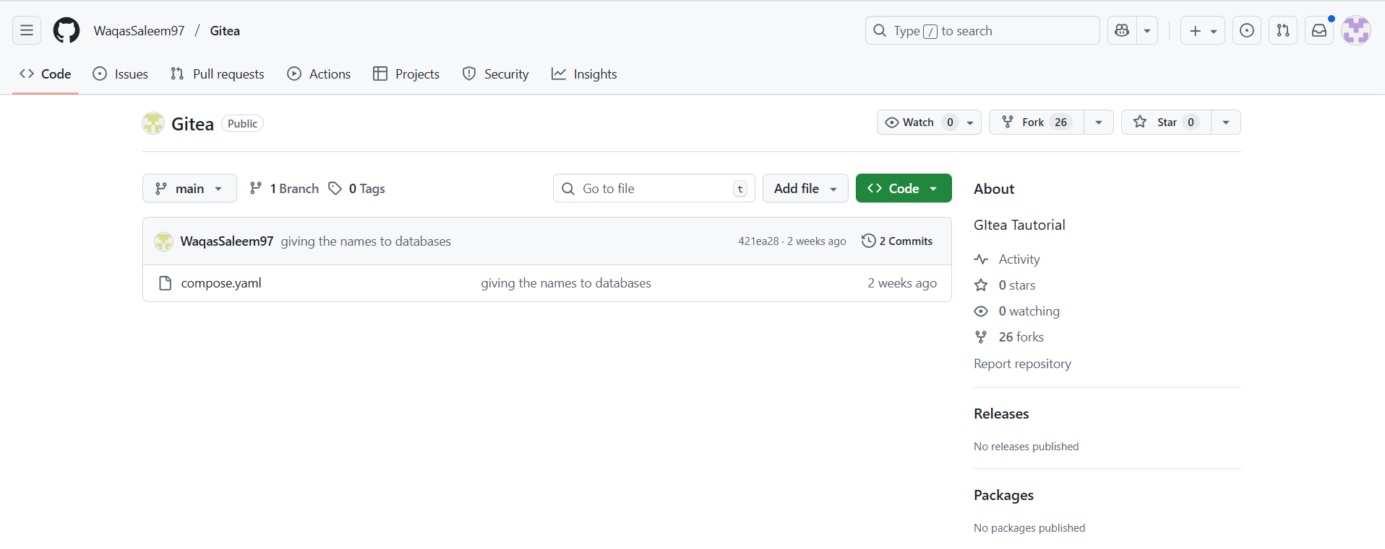
Click the Fork button at the top right and fork it into your own GitHub account.
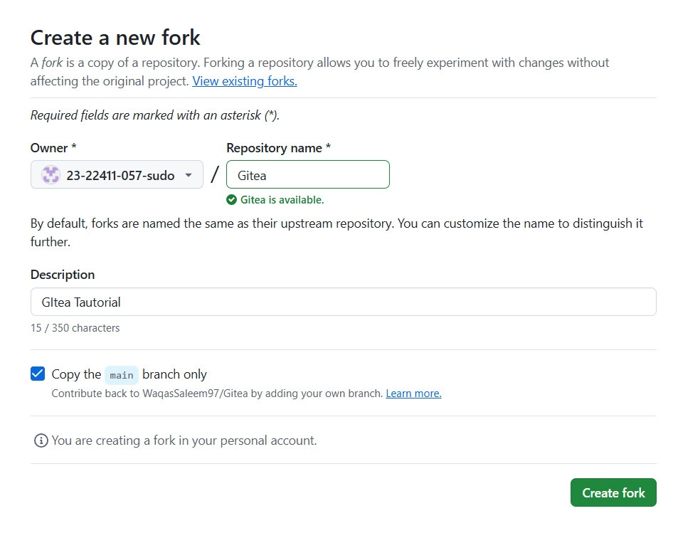
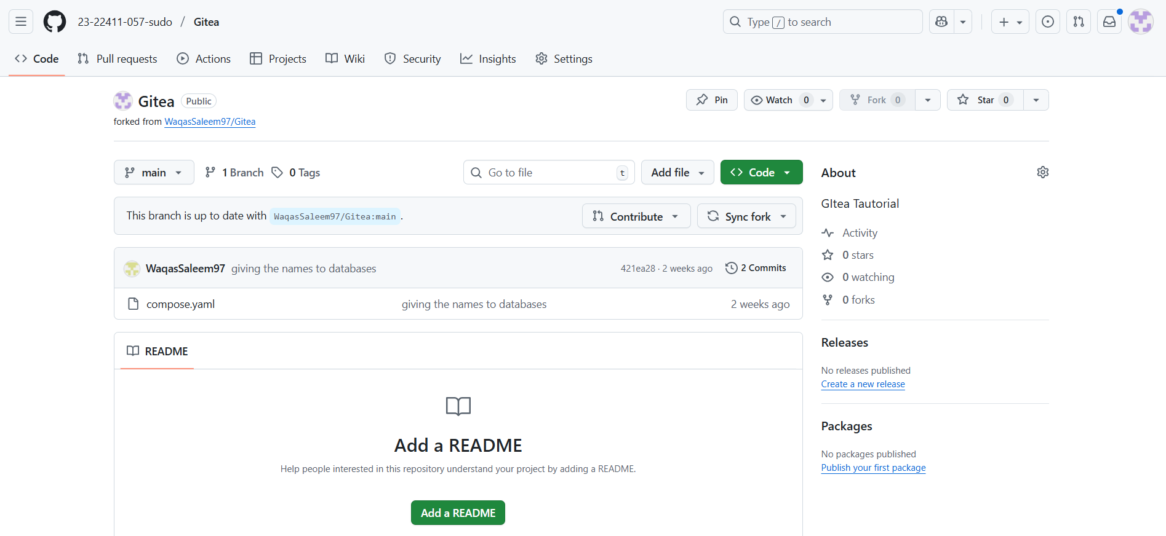
- Open the Forked Repo in GitHub Codespaces
On your forked repo, click Code > Codespaces > Create codespace on main.
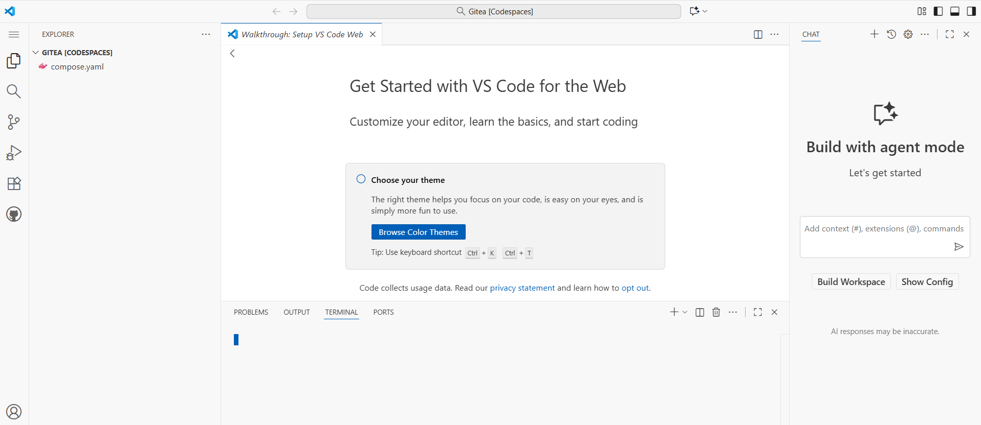
- Start Gitea with Docker Compose
In the Codespace terminal, run:
docker compose up -d
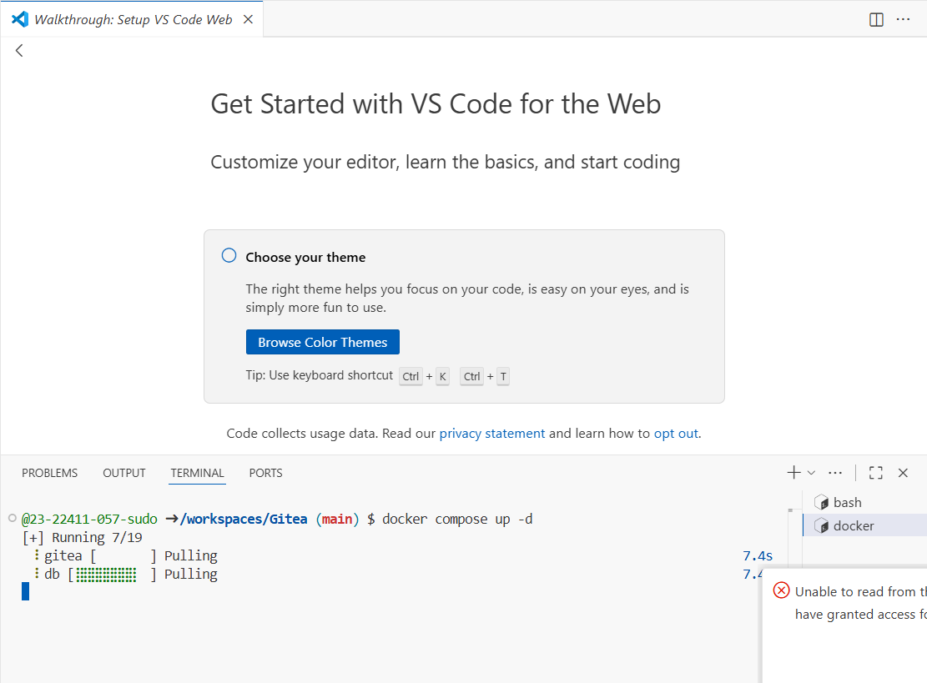
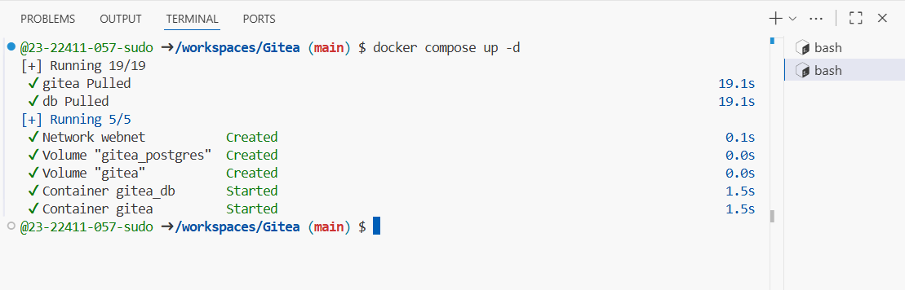
- Access Gitea Web Interface
In Codespaces, forward port 3000 (see Codespaces port forwarding UI).
Change the Visibility of port 3000 from private to public.
Click the forwarded port 3000 link to open Gitea in your browser tab.
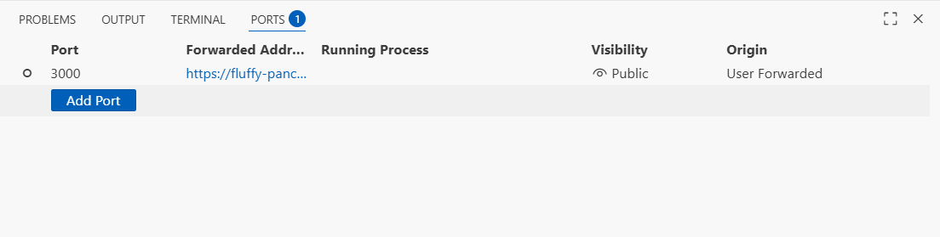
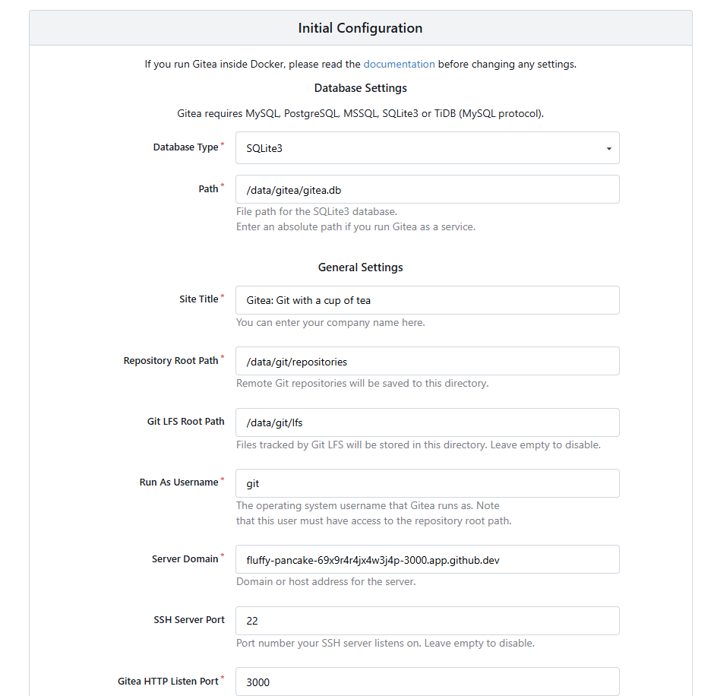
- Install Gitea
Fill out the installation form, providing an adminusername and password (e.g., admin / yourpassword).
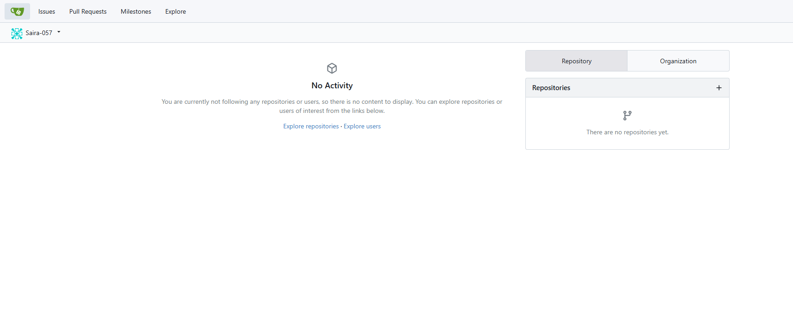
- Log In to Gitea
Use your admin credentials to log in.
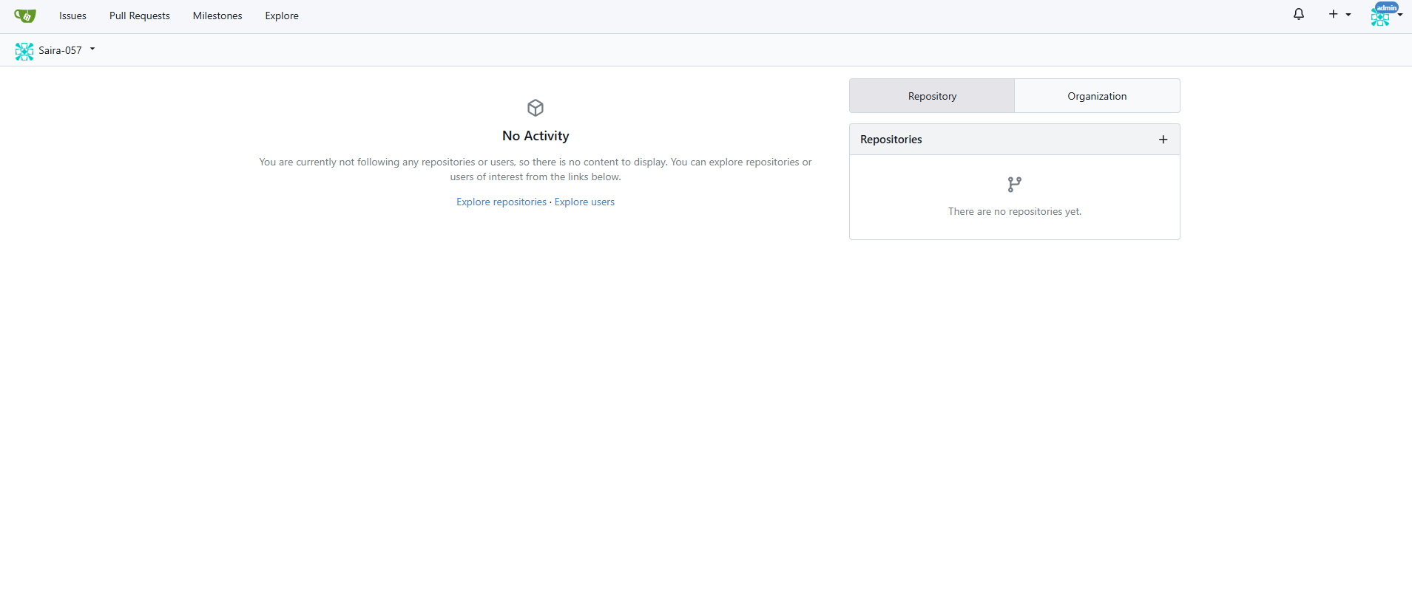
- Create a New Repository in Gitea
Click New Repository or + > New Repository in Gitea.
Fill out the repository details and create it.
Save a screenshot of the new repository page as gitea_new_repo.png.
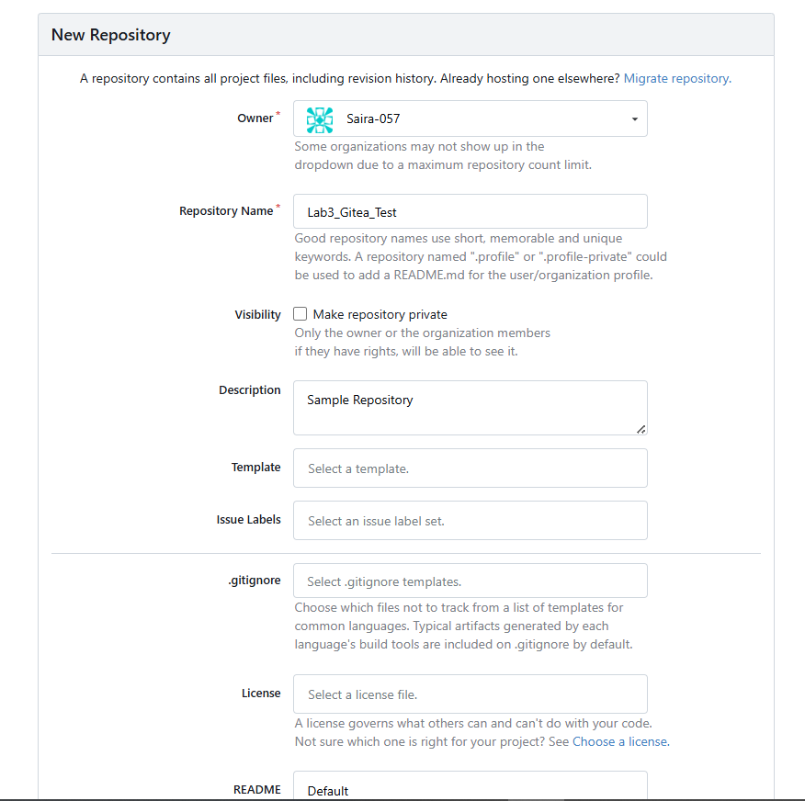
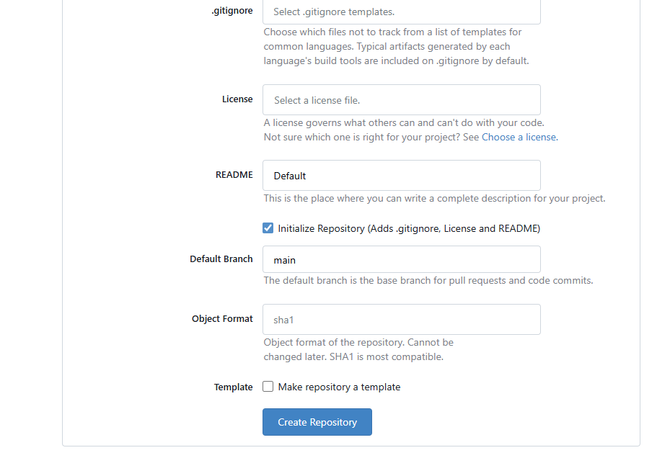
Task 11 – Creating a GitHub Pages Portfolio Site
This task will guide you through creating a personal portfolio/static site using GitHub Pages.
Steps
- Create a GitHub Pages Repository
Go to GitHub and create a new repository named <your-username>.github.io
(e.g., if your username is WaqasSaleem97, the repo should be WaqasSaleem97.github.io).
Make sure the repository is public.
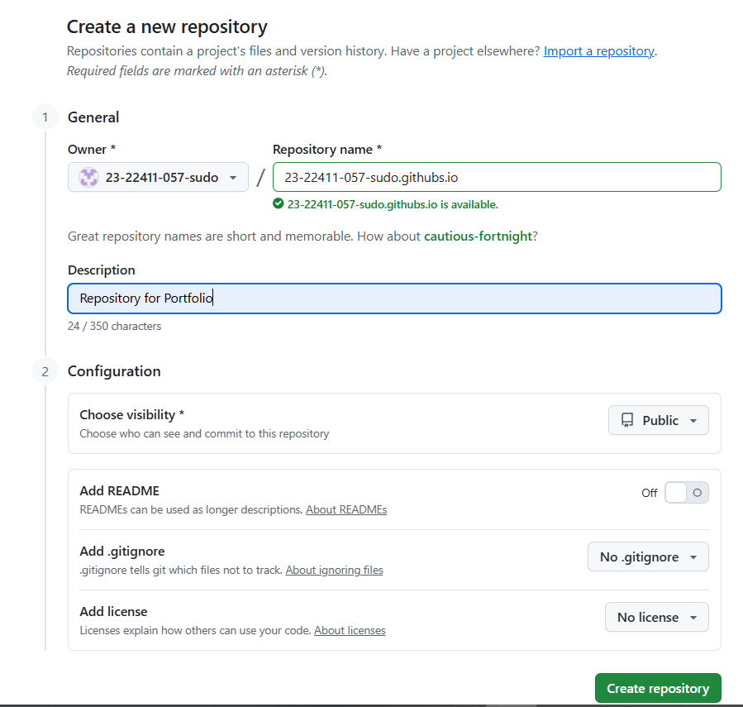
- Add Static Website Code
Prepare a simple static website (e.g., your CV or portfolio) in HTML/CSS/JS by using the sample code provided in the repository Iqra Bashir CV.
Put your files in a local folder.
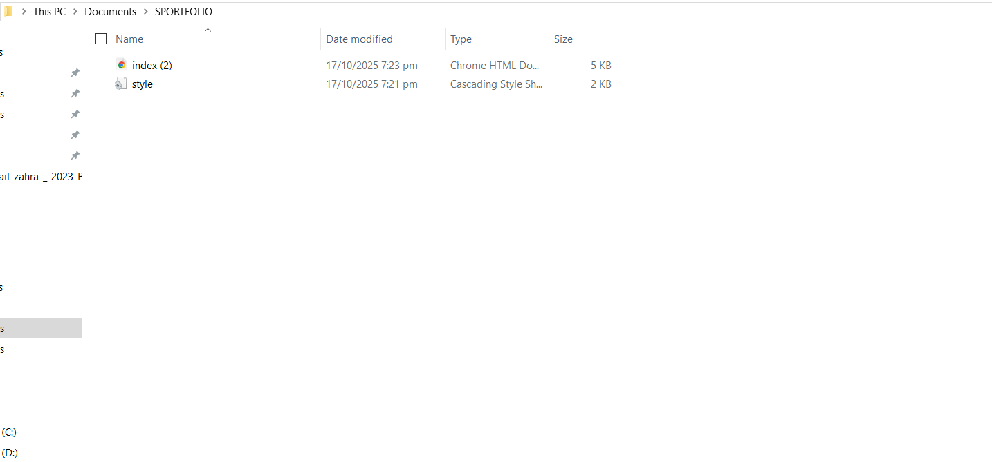
- Push the Files to GitHub
Initialize git in your folder (if not already):
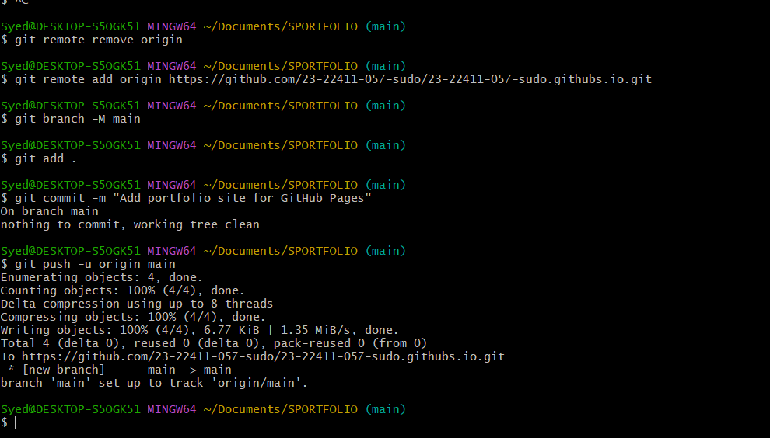
- Check GitHub Pages Settings
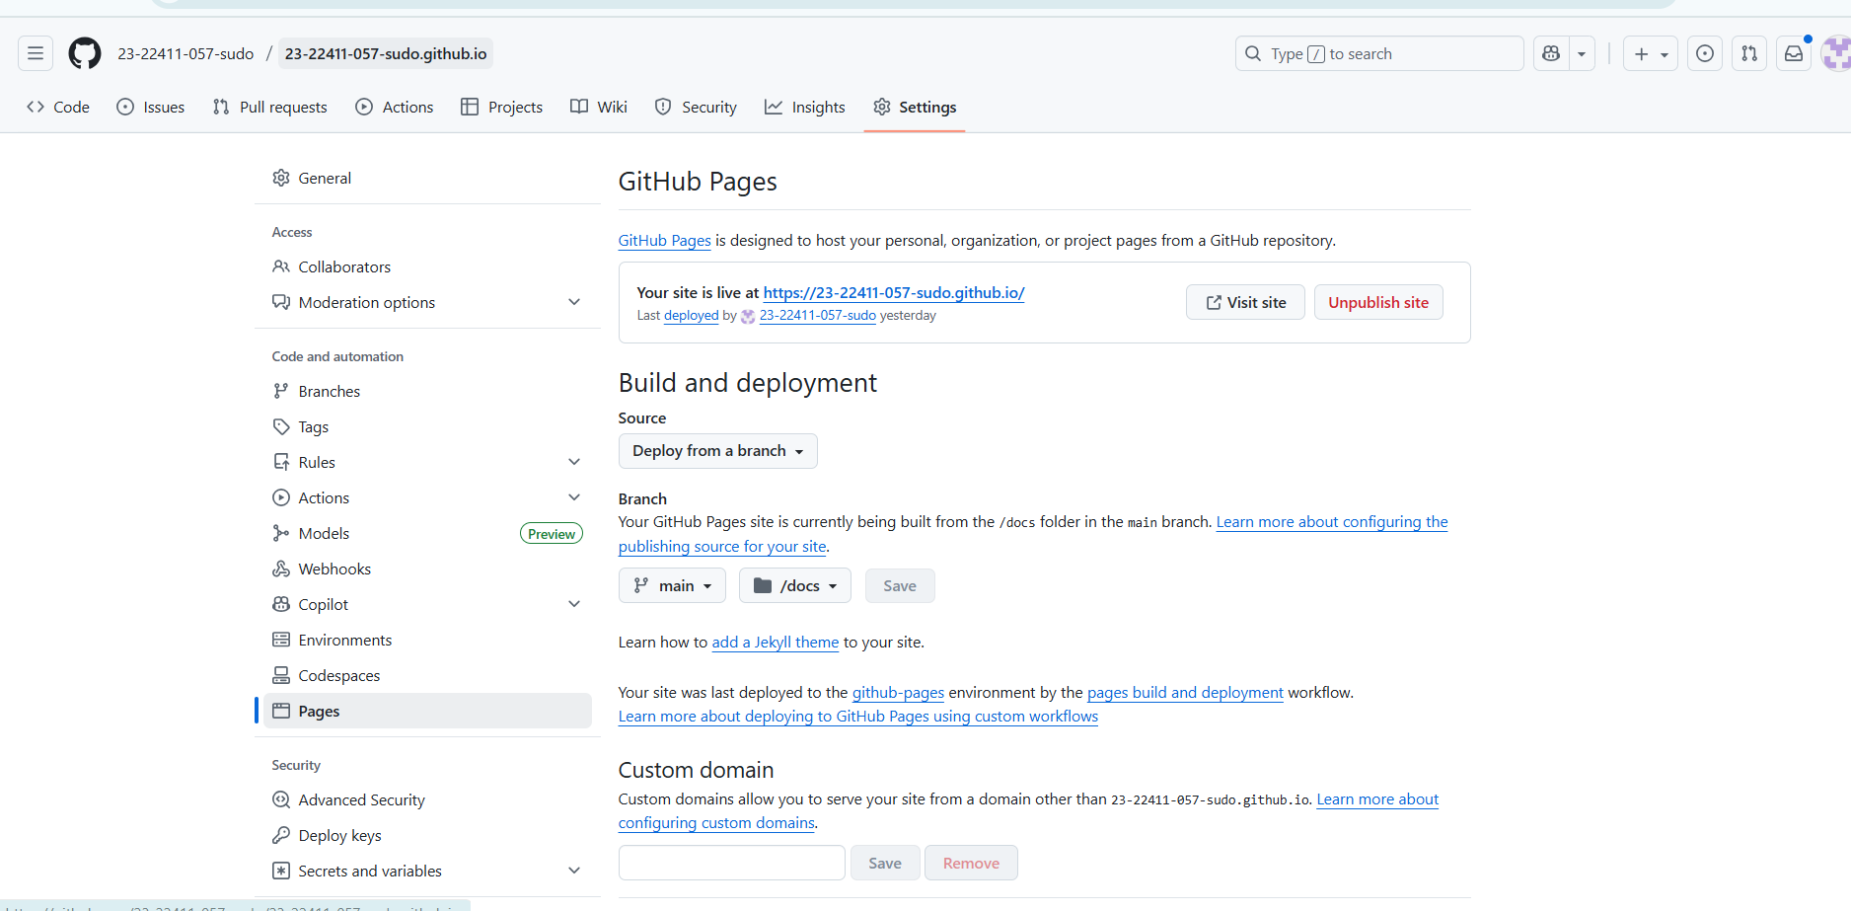

- Visit Your Live Site
Open your GitHub Pages site in the browser.
https://23-22411-057-sudo.github.io/2023-BSE-057-sudo.github.io/
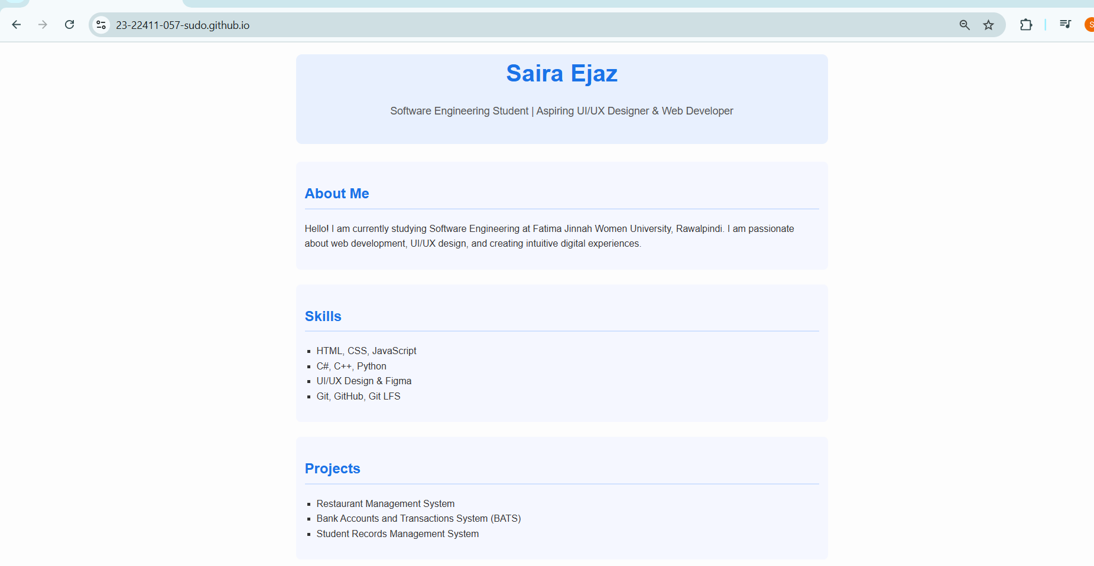
Exam Evaluation Questions
1. Local vs Remote Conflict Resolution
Steps:
- On GitHub, edit a file (e.g., README.md) and commit the change.
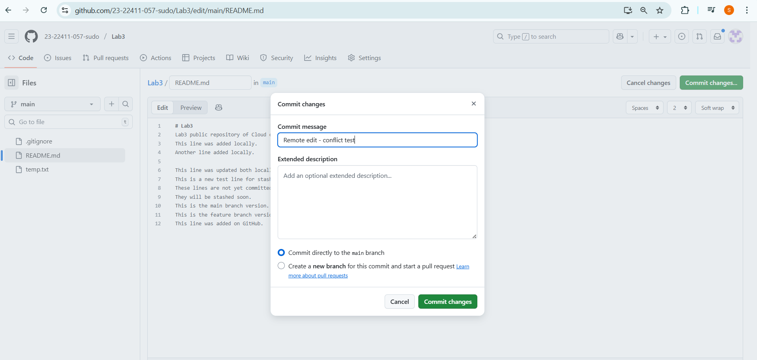
- On your local machine, edit the same file differently (Avoid Conflict) and commit.
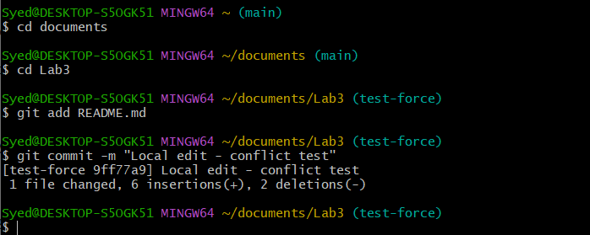
- Try to push your local commit and observe the error.
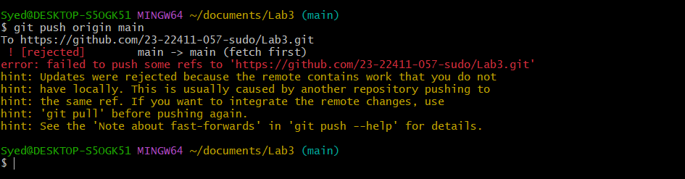
- Resolve the conflict by running git pull (merge), then push.
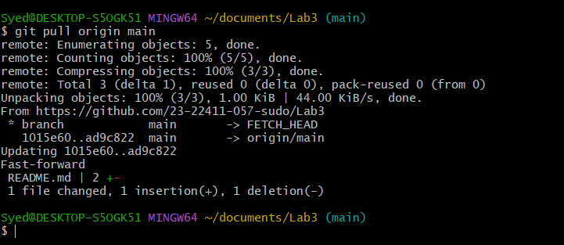
- Repeat with another remote/local change, but resolve using git pull --rebase, then push.
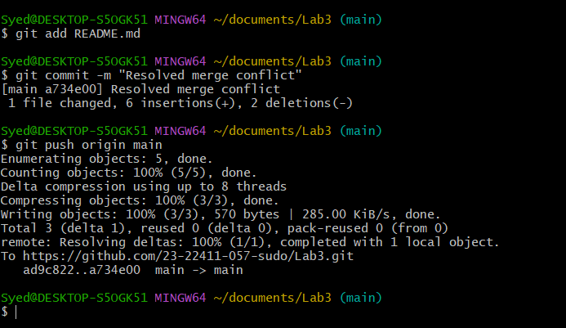
- Manual Merge Conflict Handling
Steps:
- On GitHub, change a specific line in a file and commit.

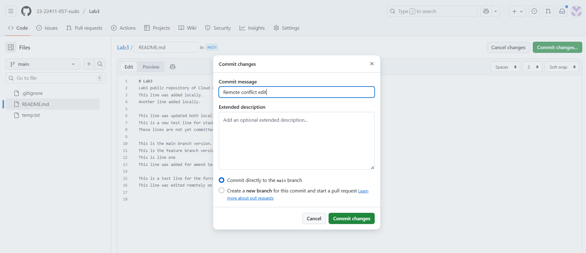
- Locally, change the same line differently and commit.
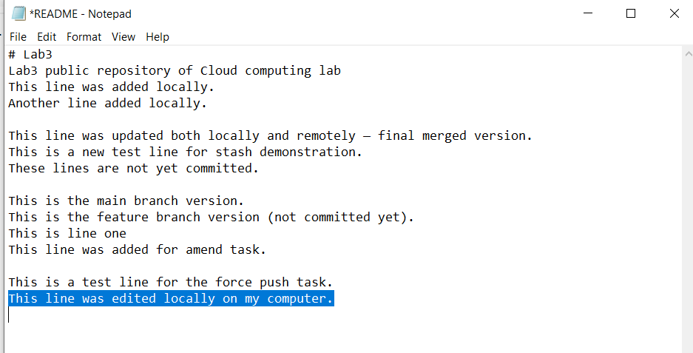
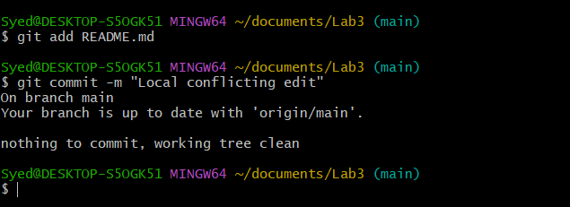
- Try to push your local change and observe the conflict error.
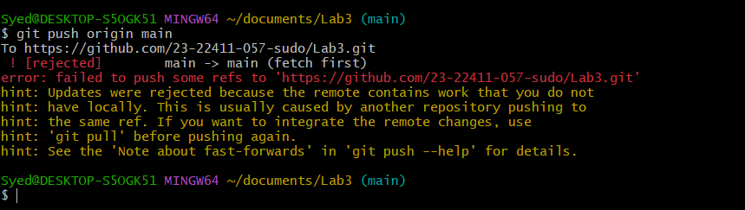
- Use git pull --rebase to fetch changes and trigger the conflict.
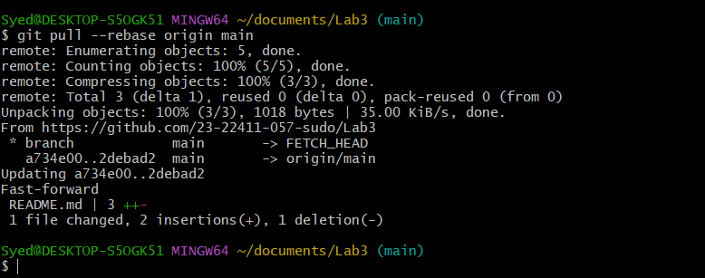
- Edit the conflicted file to resolve the conflict manually.
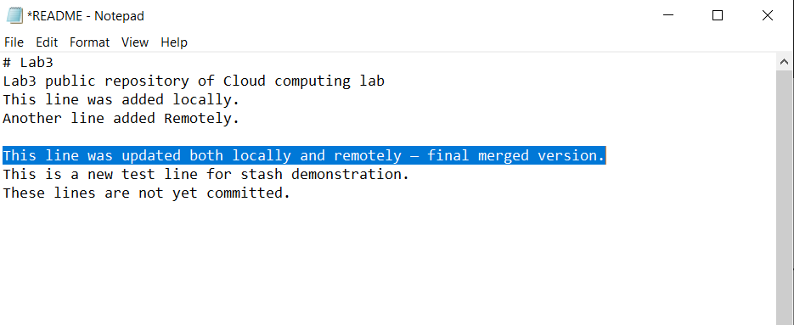
- Mark the conflict resolved (git add <file>, git rebase --continue) and push.
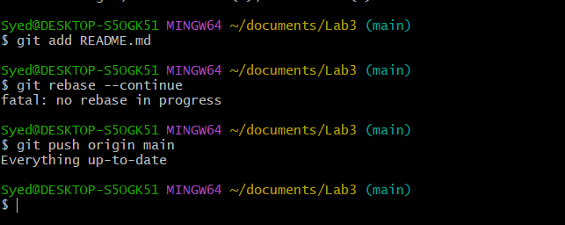
- Managing Ignored and Tracked Files
Steps:
- Create a new folder (e.g., DocFiles) and add several files inside.
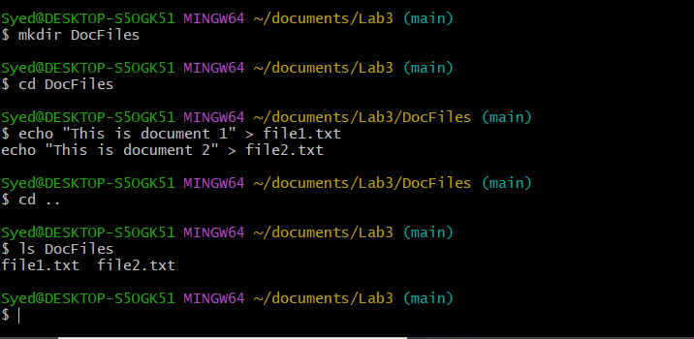
- Commit and push the folder/files to GitHub.
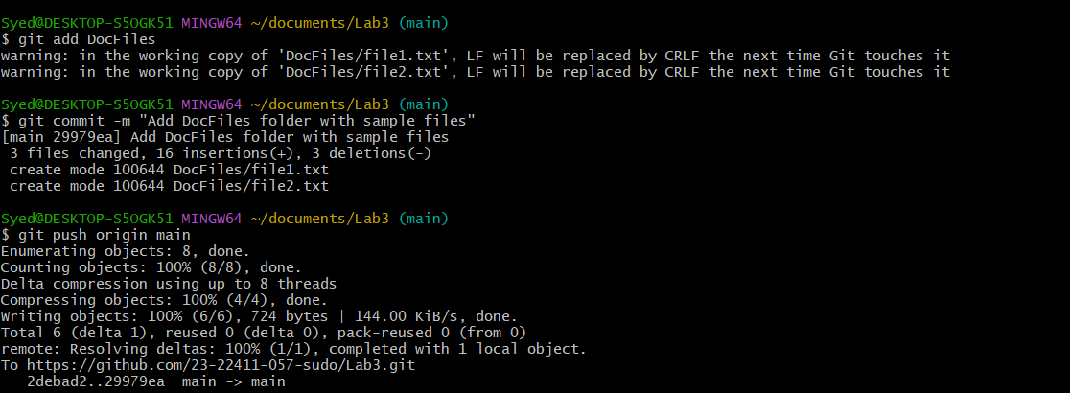
- Add the folder to your .gitignore file.
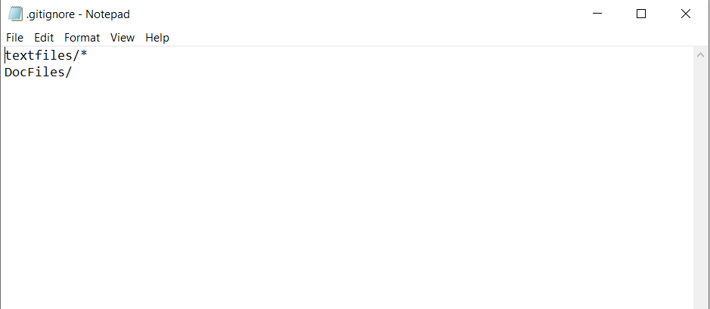
- Commit and push the .gitignore update.
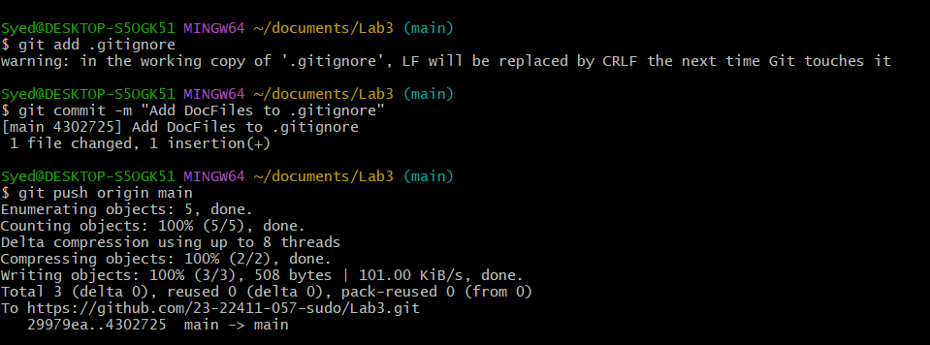
- Remove the folder from tracking using git rm -r --cached <folder>.
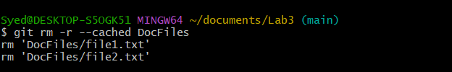
- Commit and push the change, then verify the folder is no longer tracked on GitHub.
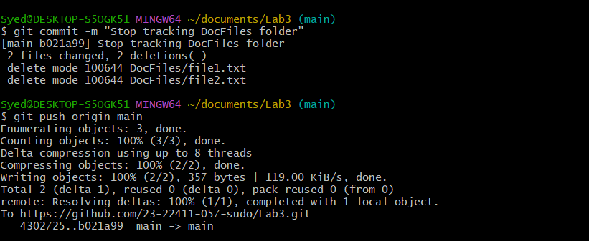
- Commit History Manipulation and Recovery
Steps:
- Make a change and commit it.
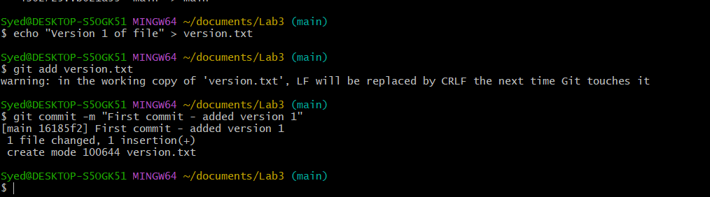
- Make another change and commit again.
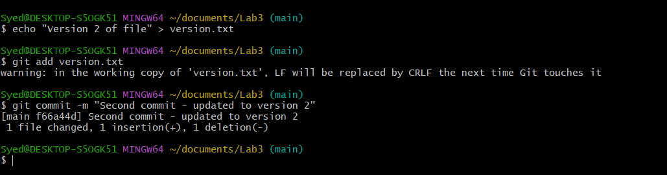
- View your commit history.
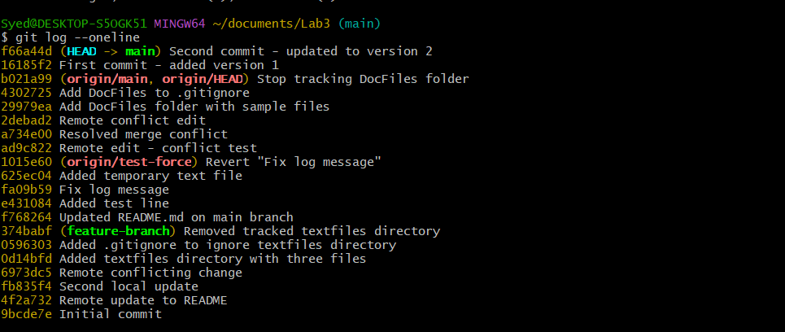
- Perform a soft reset (git reset --soft HEAD~1) and observe your file and history.
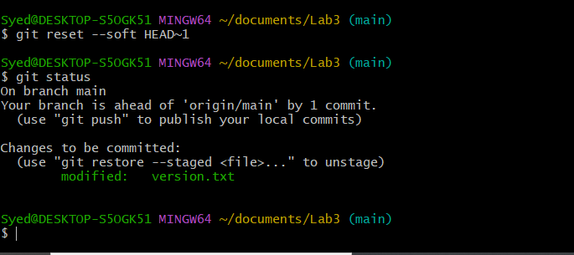
- Make commit again.
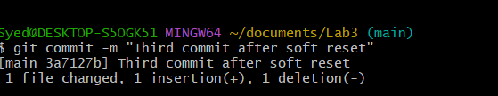
- Perform a hard reset (git reset --hard HEAD~1) and observe the changes.
